Chapter Advocacy Recognition
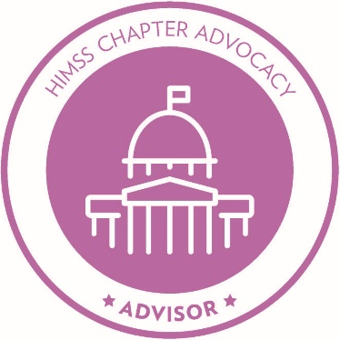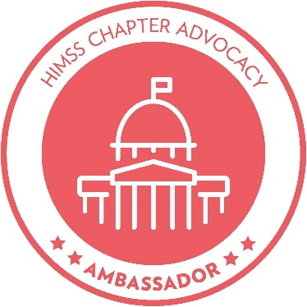
Instructions
At the end of each fiscal year, Chapter Advocates have the opportunity to apply on behalf of their chapter for Advocacy Recognition. HIMSS will present a Chapter Advocacy emblem of honor to Chapters as a direct result of their Chapter Advocate’s leadership and commitment.
HIMSS will honor eligible chapters for reaching the Advisor, Ambassador, or Changemaker level of recognition and will share the announcement through HIMSS's communication channels.
Application and Selection Process:

Eligibility: Chapter Board Members (July 1, 2020 – June 30, 2021)
- HIMSS Chapters reach a recognition level by completing the minimum requirements detailed below.
- Chapter Advocates must apply for recognition by submitting the form below and a summary/documentation of activities to policy@himss.org by, July 1, 2021.
- Please include all activities and documentation within this form or in an email with a separate file.
- HIMSS will evaluate the submissions. The team will email the qualified Chapter Advocates a certificate and emblem and will recognize the Chapters through various communication channels.

Submission Form
- Name:
- Chapter:
- Email address:
- Date submitted:
- Please highlight the level you wish to apply for. The criteria is listed under each level.

CHANGEMAKER
- At least two chapter advocates/leaders are highly involved in advocacy throughout the year and reports to the Event/Initiative Reporting Sheet on advocacy (Instructions here):
- At least one representative of the Chapter Advocacy team attends and participates in at least seven out of the ten monthly HIMSS chapter advocacy calls;
- Influences public policy and/or sustains a relationship with a key government stakeholder; and
- Completes at least ten chapter advocacy activities (Example activities below.)

AMBASSADOR
- At least one chapter advocate is invovled throughout the yer and reports to the the Event/Initiative Reporting Sheet on advocacy (Instructions here)
- At least one representative attends up to seven out of the ten monthly HIMSS chapter advocacy calls; and
- Completes at least seven chapter advocacy activities. (Example activities below.)

ADVISOR
- At least one chapter advocate is appointed/elected;
- At least one representative attends at least five of the ten monthly HIMSS chapter advocacy calls; and
- Completes at least five chapter advocacy activities (Example activities below.)

- Please complete the following page with suggested activities. For any activities checked below, please provide a brief summary and documentation of each activity. Please highlight all that apply.

Plan
- Create an advocacy action plan and regularly update Chapter Leaders on progress, successes, and challenges

Advocate
- Execute a Chapter Advocacy Day (also known as “Health IT Day”) with visits to state/provincial capitol and/or local Congressional office. See Advocacy Day Toolkit for guidance.

- Receive a resolution from your legislators or proclamation from your Governor that recognizes Chapter Advocacy Day

- Participate in or lead a virtual march and contact your legislators through the HIMSS Legislative Action Center

- Demonstrate impact on a significant policy or legislative issue related to HIMSS or state level health IT priorities (Example: Advocate for officials to leverage HIMSS’ priorities in the development of state plans or legislation)

- Invite state officials and their staff on HIMSS Davies Award or Electronic Medical Record Adoption Model (EMRAM) Stage 6 & 7-recognized facility tours or other maturity model or indicator applicants

Share
- Monitor relevant legislation and serve as a quick summary source for members and policymakers on public policy/advocacy

- Spread awareness about HIMSS’s and Chapter's mission and priorities through blogging, Chapter website, and social media

- Keep your chapters’ webpages up to date with your advocacy plan, campaigns, events, current legislative action, etc. to inform and entice members

- Thread advocacy and public policy through at least one chapter event not traditionally including these areas

- Hold event or webinar on public policy or advocacy

Collaborate
- Collaborate with chapters and other partners to achieve advocacy goals

- Participate in state/local government town halls, committees or roundtables that have shared interests and issues

- Develop and participate in advocacy workshops and share advocacy best practices, tools and resources with collaborators
- Host an advocacy intern or an advocacy activity in partnership with colleges and universities to engage students and academics and increase chapter membership

- Actively participate and represent advocacy at Chapter Leader Exchange and Chapter Workshop at HIMSS21/Global Health Conference

What did we miss? Please share what else you have accomplished:

