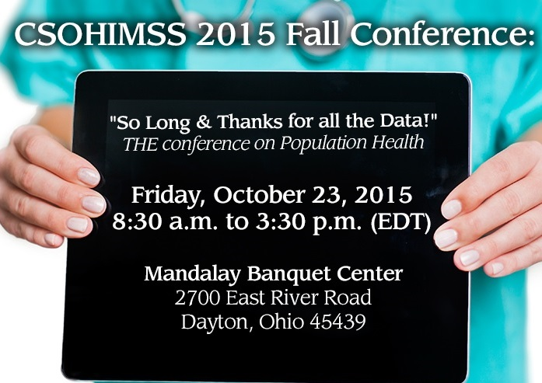 | CSOHIMSS 2015 Fall Conference  "Programming Population Health"  "Population Health - Don't Panic!"  "Comprehensive Primary Care Initiative"  "Accountable Care Obstacles: The Holy Grail of Value Based Analytics and Why We Aren't Even Close Yet"  "The Evolution of BI & Analytics at Kettering Health”  "Delivering Insights at the Point of Impact –  Population Health Management"  Healthcare Analytics, ICD-10 & the new EMR Ecosystem
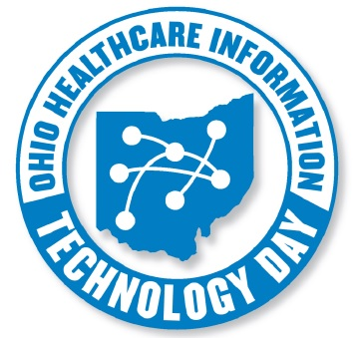 | 9th Annual OHIT Day  Wednesday, April 27, 2016  Ohio Statehouse Atrium  Columbus, Ohio  &  HIMSS Innovation Center,  Cleveland, Ohio  9:00 am – 5:00 pm  12:00 pm – 2:00 pm Luncheon Speakers
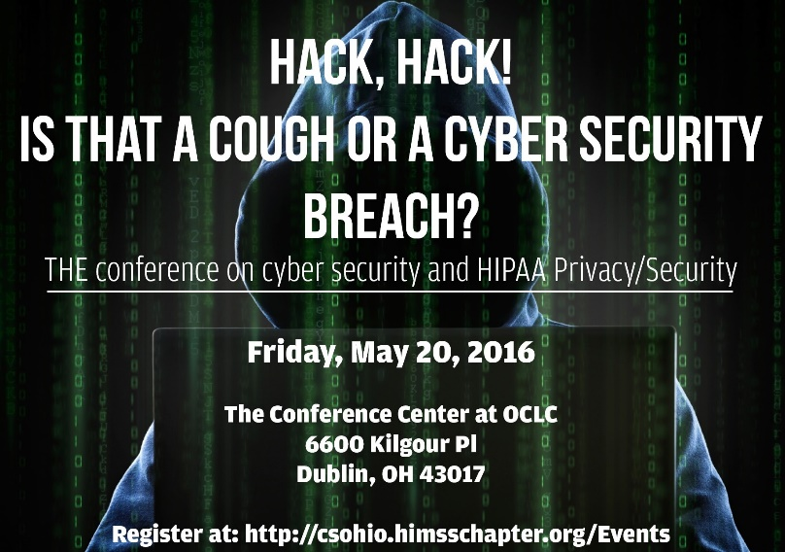 | CSOHIMSS 2015 Spring Conference  May 20, 2016, 8:30 am - 3:30 pm  Cyber Security  Health Data Breeches  HIPAA Privacy/Security  Identity  Vendor Showcase  Multiple Breakout Sessions  The Conference Center at OCLC  6600 Kilgour Pl, Dublin, OH 43017

NOHIMSS Half-Day Fall Conference:
Northern Ohio eHealth Check-up
Thursday, November 5, 2015
8:00 am - 1:00 pm
Akron Children's Hospital
215 W Bowery St
Akron, OH 44308

Ohio Health Information Exchange (HIE) Success Stories

The Cleveland Clinic HIE Experience
The Cleveland Clinic has been utilizing health information exchange with Epic’s Care Everywhere since September of 2010. Since that time, we have exchanged 3,394,363 records with over 250 different organizations across all 50 states. We have experienced significant growth and through the first 6 months of 2015, the Cleveland Clinic has exchanged 1,842,576 records. This number is up from 1,329,418 for the prior year alone.
Cleveland Clinic has increased its connections by linking with the Veterans Administration and the Social Security Administration. Our connection with VA started in February 2015 and has given our providers vital and timely information in caring for the Cleveland Clinic’s veteran population. Meanwhile, the connection with the Social Security Administration was initiated in July 2014 and has enabled patients to receive faster and more efficient turnaround time for their disability claims.
Cleveland Clinic has also seen success using Direct messaging which can facilitate sending and receiving clinical continuity of care documents. This creates the ability to exchange data nationwide with any electronic health record system with these same Direct message functionalities. Collectively, this has given our providers access to a variety of clinical information while enabling our facilities and providers to fully meet Meaningful Use standards. In addition, we offer a web based portal for outside facilities such as skilled nursing facilities and rehabilitation centers that may not have electronic health record capabilities to exchange electronically. This improves the information stream across these transitions in care. Lastly, Cleveland Clinic is working to enable data exchange with CliniSync, the Ohio based statewide HIE. This project will be fully live in the next 3-6 months; potentially connecting our Cleveland Clinic Caregivers to many other providers across our state.
Blanchard Valley Health System (BVHS) – CliniSync HIE is making Dollars and Sense
With the primary goal to have all providers and facilities working with BVHS to receive results and departmental reports through the Ohio Statewide HIE, CliniSync, BVHS identified 66 providers and facilities as candidates for using CliniSync for connection. BVHS is estimating $9,073 in savings for telecommunications costs, system interfaces costs and printing costs with only 31 of the providers and facilities underway. The ability to by-pass traditional paper-based processes and the use of the Continuity of Care Document (CCD) and electronic reports through the HIE is starting to make sense for BVHS.

