Ga HIMSS Happy Hour Networking – What does the next generation of EHRs look like?

Dee Cantrell, FHIMSS, MS, BSN, RN
Chief Information Officer
HITConsultancy, HealthAll Consulting, AdvisoryCloud
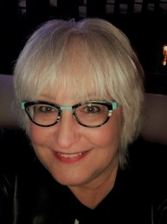

Christopher Kunney, CPHIMS, CPHIT, MSMOT
Chief of Strategy & Business Development
JUNO EHR
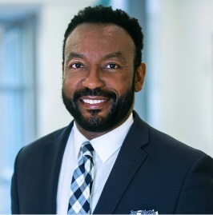

Join two of our Ga HIMSS Board Members and Health IT Industry Leaders – Dee Cantrell and Christopher Kunney – at our August Networking Happy Hour! Dee and Christopher will share insights from the recent HIMSS/DSS, Inc. study conducted on EHRs and clinician burnout and what improvements are need for the next generation of EHRs! They will also lead an engaging and fun filled discussion, come with your questions and your feedback to share! Please click here to read the white paper that shares the study results. Please plan to join this discussion on (insert date and time)!

