Texas HIMSS Advocacy Newsletter - Oct. 2023
Since 2006, U.S. National Health IT Week has brought together stakeholders in Washington, DC and across the country to demonstrate the power of information and technology to transform health. Today, HIMSS is pleased to use the power of this partner-driven platform to present Global Health Equity Week, October 23 - 27.

In the past few years, HIMSS and the health information and technology community have highlighted the role of digital health as a bridge to patient wellness by focusing on maternal health, patient identification and safety, telehealth, broadband access and public health data modernization. This year, we will continue to support those efforts as we focus upon:

- Chronic disease management
- Digital health literacy, inclusion and access ​
- Maternal health ​
- Substance use and behavioral health
- Workforce inclusion

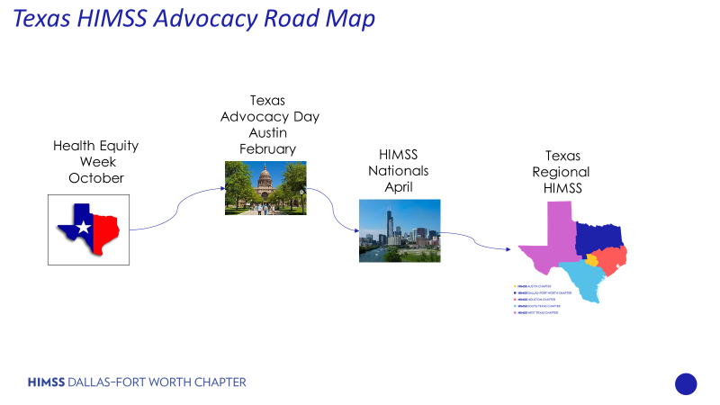

Texas HIMSS Advocacy Committee

Exciting things happening at a HIMSS Global Advocacy Level

- HIMSS has created a new Native American & Indigenous Community. More information here or contact Evan Dunne for any other inquiries

- HIMSS Report on Cross-Border Data Exchange How cross-border health data flows can create value for patients and boost health system efficiency | HIMSS

- HIMSS AI in Healthcare Forum in San Diego, CA Healthcare Forum | HIMSS

- HIMSS24 Registration is now Open! HIMSS24

Mark your calendars!

- Global Health Equity Week takes place October 23 -27, 2023. Each Texas HIMSS Chapter will be hosting an event either in person or virtual to celebrate this week, please check your local chapters websites for more information.

- Texas Advocacy Day is planned for late February in Austin, Texas. We plan to be at the Austin State Capital and talk with Legislatures and their staff. More to come ….

Pre-Global Health Equity Week

Friday October 20th

- DFW HIMSS Chapter - Fall CPHIMS/CAHIMS Prep Course
Facilitated by Tammy Phillips, VP of Professional Development 9 am - 5 pm

DFW HIMSS Events
- South Texas HIMSS Chapter - Lunch and Learn an exciting in-person event at WellMed Medical Management! This October Lunch & Learn session will feature a comprehensive recap of the latest legislation session, presented by the knowledgeable Nora Cox. Get ready to dive deep into the world of healthcare legislation and gain valuable insights 11 am - 1 pm CDT

South Texas HIMSS Events

Global Health Equity Week

Tuesday October 24th

- Austin HIMSS Chapter - Lunch and Learn Workforce Inclusion facilitated by Brian Earl Francis 12 pm - 1 pm CDT

Austin HIMSS Events

Advocacy 101 Guide - Advocacy 101, a comprehensive guide to effective advocacy strategies. Whether you're a seasoned advocate or just starting out, this series is designed to empower you with the knowledge and skills needed to make a meaningful impact in the healthcare sector.

Advocacy 101 The Guide

Next Steps for Texas HIMSS Advocacy

- Attend your local Texas HIMSS Chapters Events.
- Reach out to Your Texas HIMSS Advocacy Committee to learn how you can become more involved with Advocacy.
- Assist for the month of January and February is scheduling onsite Legislative visits and the Texas HIMSS Advocacy Committee will need help.
- Learn how to "Advocate Like Texans".
- Join your fellow Texas HIMSS Advocacy and volunteer to meet in Austin at the Texas State Capital for fellowship and then meet with Texas State Legislatives.

Your Texas HIMSS Advocacy Committee
Lee Lavergne, Pro Tem DFW HIMSS, Changemaker in Health 2023 Award Recipient. HIMSS Chapter Advocate of the Year Award,
Melinda Schmidt, VP Advocacy DFW HIMSS
Elsie Gori, VP Advocacy Austin HIMSS,
Joseph Kunisch, VP Advocacy Houston HIMSS,
Joe Chapa, Advocacy Liaison South Texas HIMSS,
Victor Pinion, VP Advocacy West Texas HIMSS,
dfw.info@himsschapter.org

